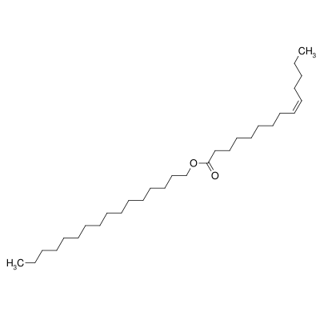

The carboxylate is Tetradecenoate
(14 C’s)
9-ene (double bond)
Z (both alkyls on same side)

Ester functionality (an alkyl carboxylate)
The alkyl is Hexadecyl
(16 C’s)

Common Name: Cetyl Myristoleate
Systematic Name: Hexadecyl (Z)-tetradec-9-enoate

